**Competitive Review of Leading TV/Movie Streaming Apps**

# **Introduction**

This report will analyze three streaming platforms to determine the flaws and benefits of Pluto TV’s personalization features. The first streaming platform that will be analyzed is Netflix. Netflix was one of the first successful streaming platforms and remains popular today. Investigating Netflix’s personalization features can reveal alternative solutions for Pluto TV. This report will also analyze Hulu. Like Netflix, Hulu is an extremely well-known and liked streaming platform. Examining Hulu and comparing it to Pluto TV may reveal a better structure for the platform. The final streaming platform is Plex TV. Like Pluto TV, Plex TV is also free, making it a good streaming service to compare to Pluto TV. The focus of this report is the personalization features of each streaming platform. Studying the personalization features of other platforms personalization features can provide insights into how to improve Pluto TV’s personalized functionalities, but Pluto TV must be properly prepared before releasing these functions to its platform.

# **Analysis**

The following section will provide a background, screenshots, and a SWOT analysis of the three streaming platforms, and compare them to Pluto TV.

## Netflix

Netflix is a subscription-based streaming platform that provides users with shows and movies. Furthermore, Netflix even provides users with award-winning originals exclusively accessible on their streaming service. Netflix’s popularity is undeniable, “boasting $8.5 billion in revenues, a substantial gain of 9 million paid subscribers, and an impressive 22.4% operating margin, the streaming giant is on a triumphant path” (Fontes). As of 2023, Netflix has 247.2 million paid subscribers worldwide. According to Statista, Hispanic and African Americans watch Netflix more than White people. Although Netflix is accessible for all ages, the majority of users fall between 18 and 54 years old.

### Strengths:

Netflix has several personalization features that make it a preferable platform for users. Firstly, Netflix allows for multiple user profiles on one account, each with personalized recommendations, a watchlist, and a viewing history, providing users with their own unique experience. Additionally, Netflix offers categories based on genres, moods, and themes, making it easier for users to discover new content. The ‘My List’ feature enables users to create a queue of movies and shows they plan to watch later, helping them keep track of content. Users can also rate movies and shows with a thumbs up or down, providing feedback that helps Netflix suggest relevant content.

Lastly, Netflix offers an offline viewing option, allowing users to download content for viewing anywhere.

### Weaknesses:

While Netflix offers many personalization benefits for users, there are also some downsides. Firstly, with a subscription plan, users are limited to the number of devices that can be included, restricting user activity and personalization and potentially causing frustration. Additionally, the recommendation feature of Netflix also runs the risk of suggesting only similar content, making it harder for users to discover new genres and interests. Netflix also tends to push popular content towards users which can limit the diversity of content suggestions. Furthermore, there is a risk of intertwined recommendations between profiles under the same account, leading to irrelevant suggestions. Lastly, there may be some privacy concerns associated with Netflix’s personalization features, as users may be uncomfortable with the amount of data used to provide personal recommendations.

### Opportunities:

While Pluto TV does allow users to make their own personal accounts, it does not allow for multiple accounts on a singular device. This limitation hinders personalization for users, as their customized options are not separated. Pluto TV offers categories, but they are confusing and misleading. Unlike Netflix, Pluto TV’s categories are random and broad. If the categories were more specific, like Netflix’s, it would be easier for users to find genres they are interested in. Pluto TV lacks a feature similar to Netflix’s thumbs-up and down button, resulting in less feedback for the platform to determine users’ interests. Additionally, Pluto TV does not offer offline access to its shows and movies, limiting its accessibility for users.

### Threats:

Enhancing Pluto TV’s personalization feature may increase the risk of limiting the diversity of content users are exposed to, potentially causing limited exploration and reduced engagement. Since Pluto TV is free, it may struggle to implement advanced enough technology to store data for multiple profiles under one account, potentially leading to the introduction of a subscription model. Additionally, implementing multiple profiles could result in the possibility of incorrect recommendations for users. Without advanced personalization features, Pluto TV can build more trust with users as they do not feel like their privacy is being invaded.

## Hulu

Hulu is a popular streaming service with live TV and on-demand content. It has a large variety of shows, movies, and originals, with access to over 90+ channels. The majority stake in Hulu is owned by Disney, and Comcast owns the other 33 percent. Hulu was reported to have, “around 48 million paid subscribers” (Stoll). In contrast, Pluto TV, despite being US-based, has only 4.5 million users in America. Gender distribution among Hulu subscribers is fairly equal, “52% of Hulu subscribers are female, while 48% are male” (Dean). The platform’s user base primarily consists of millennials of Generation Z.

### Strengths:

Hulu offers several methods for personalizing its platform. Firstly, it provides profiles that track viewing history and offer content recommendations, ensuring that each user can have their own unique experience. Similar to Netflix, Hulu also offers recommendations based on the user’s viewing history and preferences, helping them discover new content aligned with their interests. Additionally, Hulu offers live TV personalization, recommending channels based on users’ engagement with live TV, thereby enabling users to find channels they like faster and reducing frustration. These personalized recommendations result in a customized home screen for each profile, enhancing the distinct experience. Lastly, Hulu personalizes ads to cater to users’ interests.

### Weaknesses:

Compared to Netflix, Hulu’s library content is not as extensive, limiting the variety of personal recommendations for users. Consequently, users may find themselves receiving repeated recommendations, disrupting the flow of interesting new content and creating frustration. Additionally, Hulu has limited international accessibility, which may restrict users’ unique experiences. For instance, frequent travelers or users residing outside the US may encounter limitations in accessing Hulu TV. Lastly, there may be some privacy concerns with Hulu’s personalization features, as they rely on capturing personal data.

### Opportunities:

If Pluto TV were to begin creating multiple profiles under one account, it would allow for data to be separated between each user, creating a sense of individuality since users would no longer share data with others using the same device. Pluto TV would benefit from adding personalized recommendations, enabling users to find shows and movies of their interest much faster, thus increasing user engagement. By incorporating recommendations, Pluto TV would also provide users with their own personalized home screen, improving user satisfaction and time efficiency when using the platform. Adapting a feature like Hulu’s live TV personalization would further benefit users in finding their favorite channels faster. One of Pluto TV’s biggest complaints is its ads, so having personalized ads may enhance users’ experience and reduce frustration.

### Threats:

Unlike Hulu, Pluto TV is available in multiple countries, making it more accessible to people worldwide. This allows users to enjoy Pluto TV regardless of their location or lifestyle. Additionally, since Pluto TV does not offer advanced personalization recommendations, it fosters more trust among users, as they do not feel their privacy is being invaded.

## Plex TV

Plex TV is a streaming platform that provides users with “… one place to find and access all the media that matters to you” (Plex TV). It offers a wide range of content, including movies, shows, live TV, and music. Plex is accessible on multiple devices and allows users to track and organize their media. It is a global streaming platform available in over 200 countries, boasting 20 million viewers. Premium features are available with the purchase of a Plex Pass. The annual revenue for Plex TV ranges between 15 million and 25 million. It is primarily known for its streaming and online TV services.

### Strengths:

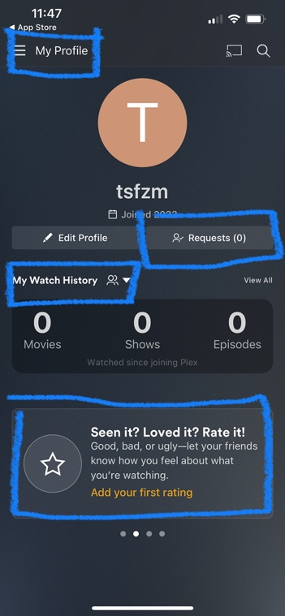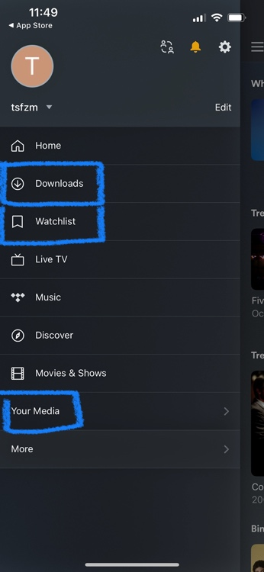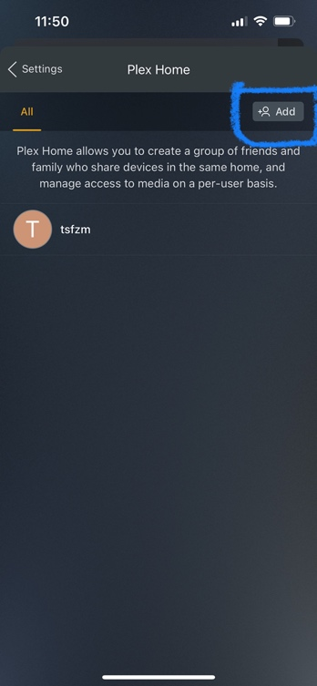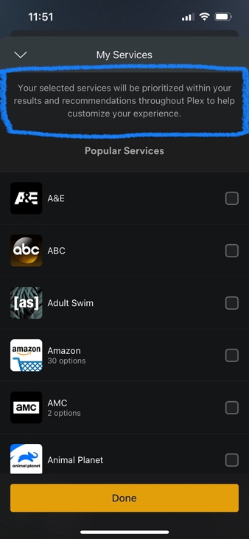

Firstly, like the other platforms, Plex TV allows users to create multiple profiles under one account, providing users with profiles organized around their interests. Each profile on Plex TV allows users to create their own personal libraries, enabling them to curate their own personalized media collection including music, photos, and home videos, thereby creating a unique experience. Additionally, it allows users to customize their own collections based on genres, themes, moods, and other criteria, empowering them to personalize their accounts themselves.

Similar to other platforms, Plex TV also features a recommendation system called Plex Picks. Moreover, it offers a ‘watch together’ feature that enables family and friends to watch shows and movies together, regardless of their location. This allows users to create their own personalized group viewing experience. Additionally, users can add other users as friends, allowing them to view each other’s recommendations.

Lastly, Plex TV allows users to record live broadcasts, ensuring that they will not miss any content they wish to watch. Users can also select preferred channels, and Plex TV will customize their page to enhance their viewing experience.

### Weaknesses:

Similar the other platforms, Plex TV also faces the risk of advertising the same or similar shows and movies through their Plex Picks. This can lead to less diversity in the content provided to users and make it challenging for them to explore new genres and interests. Additionally, Plex TV’s personalization features often rely on user-owned content created in their media library. If users do not utilize this feature, personalized recommendations may be inaccurate. Lastly, Plex TV lacks a feature to personalize live TV, making it difficult for users to discover channels they may be interested in.

### Opportunities:

Enabling users to create their own personal libraries would strengthen Pluto TV as a platform, as it would facilitate the identification of users’ likes and interests. Customizable collections would provide users with a more personalized home screen, thereby increasing their engagement with the content. Additionally, incorporating recommendations into Pluto TV would help users discover new shows and movies aligned with their interests, eliminating the need for manual searching. The ‘watch together’ feature could be particularly valuable for Pluto TV, as it would enable families and friends who do not live near each other to enjoy a personalized viewing experience together. Furthermore, allowing users to record live content on Pluto TV would provide them with the flexibility to watch their shows and movies at their convivence, even if they are unable to watch them when they air.

### Threats:

The absence of personalized recommendation features on Pluto TV prevents the issue of repetitive content or genres dominating the user’s home screen, thereby allowing for exposure to a more diverse range of content. Additionally, by not implementing recommendations, Pluto TV avoids the need to rely on user interactions within the platform, which can lead to inaccuracies in the provided content.

### **Conclusion**

The analysis of these three platforms (Netflix, Hulu, and Plex TV) highlights the strengths, weaknesses, opportunities, and threats of their personalization features. Understanding this analysis can provide insights into enhancements that Pluto TV could adapt to make its streaming platform more personalized for users, thus enhancing the overall user experience. Implementing the personalization features utilized by other platforms (multiple profiles, direct and clear categories, recommendations, rating features, and social viewing options) can improve users’ experience. However, Pluto TV must be mindful that acquiring these features will require more advanced technology and a restructuring of its website, which may require additional expenses. Therefore, it is important Pluto TV only implement these features if they are confident and secure in the new technology. This is vital since these functions require personal data and can potentially limit the type of content users are exposed to. If these features do not function properly, they could potentially worsen the user experience.

# **References**

Dean, B. (2023, March 27). *Hulu viewership and subscriber statistics: How many people watch hulu in 2023?*. Backlinko. https://backlinko.com/hulu-users

Fontes, K. Netflix stock: 3Q earnings were beautiful, what’s next? (n.d.). https://www.thestreet.com/streaming/nflx/netflix-stock-3q-earnings-were-beautiful-whats-next-

Plex.tv traffic analytics, ranking stats & tech stack | similarweb. (n.d.-b). https://www.similarweb.com/website/plex.tv/

*Product facts*. Plex. (2022, April 8). https://www.plex.tv/press/product-facts/

Stoll, J. (2023, October 19). *Netflix: Number of subscribers worldwide 2023*. Statista. https://www.statista.com/statistics/250934/quarterly-number-of-netflix-streaming-subscribers-worldwide/#:~:text=Netflix%20had%20around%20247.2%20million,compared%20with%20the%20previous%20quarter

Stoll, J. (n.d.). *Topic: Hulu*. Statista. https://www.statista.com/topics/4262/hulu/#topicOverview

*Watch Live TV Online - Stream Live & On-Demand*. Hulu. (n.d.). https://www.hulu.com/start/klay-livetv

*What is plex?*. Plex Support. (2022, November 30). https://support.plex.tv/articles/200288286-what-is-plex/#:~:text=Plex%20gives%20you%20one%20place,one%20app%2C%20on%20any%20device